Екзаменаційна робота

студента групи ІК-11

<*Снігура Стефана Андрійовича*>

з предмету

«Алгоритмізація та програмування»

**1. (6.2)**

**Умова завдання:**

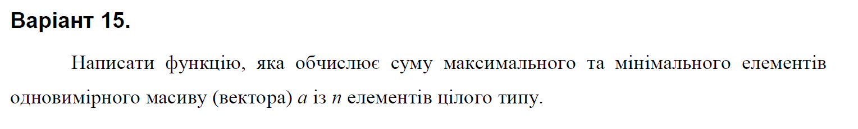

**Текст програми:**

#include <iostream>

#include <iomanip>

#include <time.h>

using namespace std;

void arr_create(int* arr, int const size, int const min, int const max)

{

for (int i = 0; i < size; i++) {

arr[i] = min + rand() % (max - min + 1);

}

}

void arr_out(int* arr, int const size)

{

for (int i = 0; i < size; i++) {

cout << setw(4) << arr[i];

}

cout << endl;

}

int max_number(int* arr, int const size)

{

int max_num = arr[0];

for (int i = 0; i < size; i++)

if (arr[i] > max_num)

max_num = arr[i];

return max_num;

}

int min_number(int* arr, int const size)

{

int min_num = arr[0];

for (int i = 0; i < size; i++)

if (arr[i] < min_num)

min_num = arr[i];

return min_num;

}

int sum_number(int max, int min)

{

return (max + min);

}

int main() {

const int min = -100;

const int max = 100;

srand((unsigned)time(NULL));

const int n = 25;

int a[n];

arr_create(a, n, min, max);

arr_out(a, n);

cout << endl;

max_number(a, n);

int max_n = max_number(a, n);

cout << "The greatest number = " << max_n << endl;

cout << endl;

min_number(a, n);

int min_n = min_number(a, n);

cout << "The lowest number = " << min_n << endl;

cout << endl;

sum_number(max_n, min_n);

int sum_num = sum_number(max_n, min_n);

cout << "The sum of the greatest and the lowest numbers = " << sum_num;

cout << endl;

}

**2. (7.2)**

**Умова завдання:**

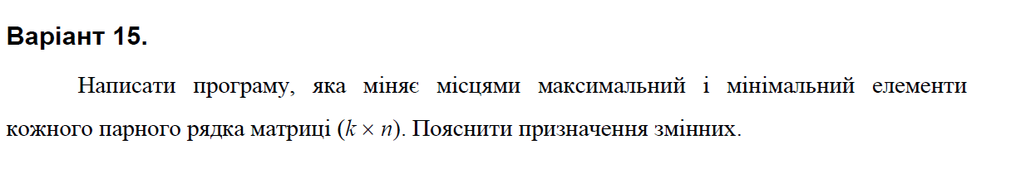**Текст програми:**

#include <iostream>

#include <iomanip>

#include <time.h>

using namespace std;

void Create(int** a, const int rowCount, const int colCount, const int Low, const int High);

void Print(int** a, const int rowCount, const int colCount);

void ChangeMinRow(int** a,int& n,const int rowCount, const int colCount, int min, int max);

int main()

{

srand((unsigned)time(NULL));

int Low = -30;

int High = 30;

int rowCount; cout << "length = "; cin >> rowCount;

int colCount; cout << "width = "; cin >> colCount;

int n;

int** a = new int* [rowCount];

for (int i = 0; i < rowCount; i++)

a[i] = new int[colCount];

Create(a, rowCount, colCount, Low, High);

Print(a, rowCount, colCount);

ChangeMinRow(a, n, rowCount, colCount, 0, 0);

Print(a, rowCount, colCount);

return 0;

}

void Create(int** a, const int rowCount, const int colCount, const int Low, const int High)

{

for (int i = 0; i < rowCount; i++)

for (int j = 0; j < colCount; j++)

a[i][j] = Low + rand() % (High - Low + 1);

}

void Print(int** a, const int rowCount, const int colCount)

{

cout << endl;

for (int i = 0; i < rowCount; i++)

{

for (int j = 0; j < colCount; j++)

cout << setw(4) << a[i][j];

cout << endl;

}

cout << endl;

}

void ChangeMinRow(int** a, int& n, const int rowCount, const int colCount, int min, int max)

{

for (int i = 1; i < rowCount; i+=2) {

min = a[i][0];

max = a[i][0];

int kmax = 0;

int kmin = 0;

for (int j = 1; j < colCount; j++ ){

if (a[i][j] > max){

max = a[i][j];

kmax = j;

}

if (a[i][j] < min) {

min = a[i][j];

kmin = j;

}

}

a[i][kmax] = min;

a[i][kmin] = max;

}

}

**3. (8.1 іт.)**

**Умова завдання:**

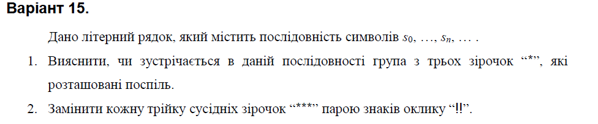

**Текст програми:**

#include <iostream>

using namespace std;

bool Include(const char* s, const char c)

{

for (int i = 0; s[i] != '\0'; i++)

if (c == s[i] && c == s[i + 1] && c == s[i + 2])

return true;

return false;

}

char* Change(char* str)

{

size_t len = strlen(str);

if (len < 3)

return str;

char* tmp = new char[len + 1];

char* t = tmp;

tmp[0] = '\0';

size_t i = 0;

while (i < len && str[i + 2] != 0)

{

if (str[i] == '*' && str[i + 1] == '*' && str[i + 2] == '*')

{

strcat_s(t, len + 1, "!!");

t += 2;

i += 3;

}

else

{

*t++ = str[i++];

*t = '\0';

}

}

*t++ = str[i++];

*t++ = str[i++];

*t = '\0';

strcpy_s(str,len + 1, tmp);

return tmp;

}

int main()

{

char str[101];

char c = '*';

cout << "Enter string:" << endl;

cin.getline(str, 100);

char* dest = new char[151];

cout << endl;

if (Include(str, c))

cout << "String has 3 * in a row" << endl;

else

cout << "String hasn`t 3 * in a row" << endl;

cout << endl;

dest = Change(str);

cout << "Modified string (param) : " << str << endl;

cout << "Modified string (result): " << dest << endl;

return 0;

}

**4. (10.1)**

**Умова завдання:**

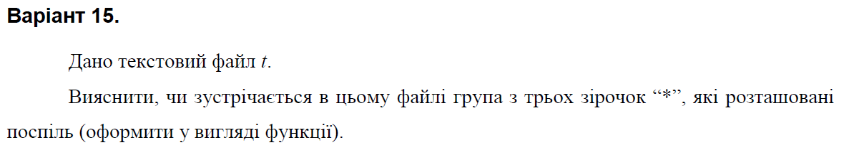

**Текст програми:**

#define _CRT_SECURE_NO_WARNINGS

#include <iostream>

#include <fstream>

#include <string>

using namespace std;

bool Include(string s, const char c)

{

for (int i = 0; s[i + 2] != '\0'; i++)

if (c == s[i] && c == s[i + 1] && c == s[i + 2])

return true;

return false;

}

void CreateTXT(char* fname)

{

ofstream fout(fname);

char ch;

string s;

do

{

cin.get();

cin.sync();

cout << "enter line: "; getline(cin, s);

fout << s << endl;

if (Include(s, '*'))

cout << "String has 3 * in a row" << endl;

else

cout << "String hasn`t 3 * in a row" << endl;

cout << endl;

cout << "continue? (y/n): "; cin >> ch;

} while (ch == 'y' || ch == 'Y');

}

void PrintTXT(char* fname)

{

ifstream fin(fname);

string s;

while (getline(fin, s)) // поки можна зчитувати рядок

{

cout << s << endl;

}

cout << endl;

}

int main()

{

char t[100];

char c = '*';

cout << "enter file name 1: "; cin >> t;

CreateTXT(t);

PrintTXT(t);

return 0;

}

**5. (11.1)**

**Умова завдання:**

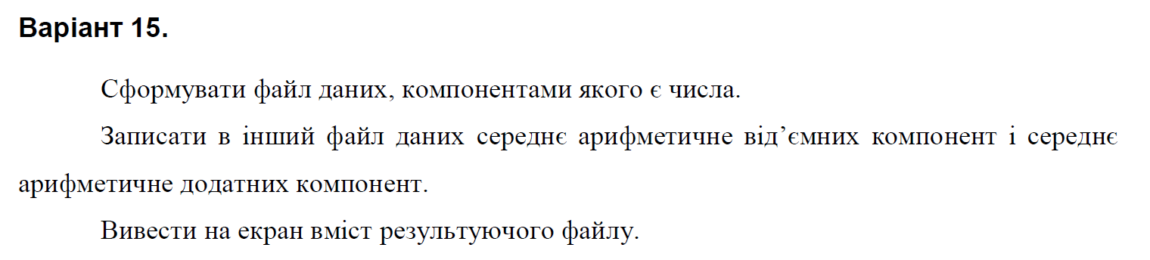

**Текст програми:**

#include <iostream>

#include <fstream>

#include <string>

#include <cmath>

#include <math.h>

using namespace std;

void CreateBIN(char* fname)

{

ofstream fout(fname, ios::binary);

char ch;

int n;

cout << "Enter number of elements: "; cin >> n;

double* s = new double[n];

do

{

cin.get();

cin.sync();

cout << "enter line: ";

for (unsigned i = 0; i < n; i++) {

cin >> s[i];

fout.write((char*)&s[i], sizeof(s[i]));

}

cout << "continue? (y/n): "; cin >> ch;

} while (ch == 'y' || ch == 'Y');

cout << endl;

}

void PrintBIN(char* fname)

{

ifstream fin(fname, ios::binary);

double c;

while (fin.read((char*)&c, sizeof(c)))

{

cout << c << endl;

}

cout << endl;

}

double ProcessBIN(char* fname, char* gname) {

ifstream f(fname, ios::binary);

ofstream g(gname, ios::binary);

double c;

double s = 0;

double sk = 0;

double p = 0;

double pk = 0;

while (f.read((char*)&c, sizeof(c)))

{

if (c > 0) {

s += c;

sk++;

}

if (c < 0) {

p = p + c;

pk++;

}

}

double avgs = s / sk;

double avgp = p / pk;

g.write((char*)&avgs, sizeof(avgs));

g.write((char*)&avgp, sizeof(avgp));

return 0;

}

int main()

{

//

char fname[100];

cout << "enter file name 1: "; cin >> fname;

CreateBIN(fname);

PrintBIN(fname);

char gname[100];

cout << "enter file name 2: "; cin >> gname;

ProcessBIN(fname, gname);

PrintBIN(gname);

return 0;

}